Python Course Project Report

Title: COVID-19 Data Visualization using Python
Type: Original Work
Author: Kazi Md Kamrul Islam Shawn
Institution: Beijing Institute of Technology

1. Topic Significance and Background
COVID-19 has been one of the most significant global events in recent years, affecting millions of lives. Analyzing and visualizing pandemic data helps people and researchers understand how cases evolve over time in different countries or regions. This project uses Python data analysis tools to visualize real-time COVID-19 statistics, showing how programming and visualization transform data into meaningful insights.

2. Project Goals
- Retrieve real-time or recent COVID-19 statistics using an API.
- Display the most affected countries using clear, visual charts.
- Strengthen understanding of data processing and visualization in Python.
- Build a clean, easy-to-read graphical output.

3. Design Process
Tools and Libraries: Python 3.x, Requests, Pandas, Matplotlib, VS Code / Jupyter Notebook.
System Flow:
+-----------------------------+
| Fetch COVID data from API |
+-------------+---------------+
|
v
+-----------------------------+
| Process data with pandas |
+-------------+---------------+
|
v
+-----------------------------+
| Plot graphs with matplotlib |
+-----------------------------+

4. Core Source Code
import requests
import pandas as pd
import matplotlib.pyplot as plt
url = "https://disease.sh/v3/covid-19/countries"
try:
response = requests.get(url, timeout=10)
data = response.json()
df = pd.DataFrame(data)
top_countries = df.sort_values("cases", ascending=False).head(10)
plt.figure(figsize=(10, 6))
plt.bar(top_countries["country"], top_countries["cases"], color='orange')
plt.title("Top 10 Countries by Total COVID-19 Cases", fontsize=14)
plt.xlabel("Country")
plt.ylabel("Total Cases")
plt.xticks(rotation=45)
plt.tight_layout()
plt.show()
plt.figure(figsize=(8, 8))
plt.pie(top_countries["deaths"], labels=top_countries["country"],
autopct='%1.1f%%', startangle=140)
plt.title("COVID-19 Death Distribution among Top 10 Countries")
plt.show()
except Exception as e:
print("Error fetching or visualizing data:", e)

5. Operation Screenshots and Description
1. Screenshot 1: Bar chart showing top 10 countries by total confirmed cases.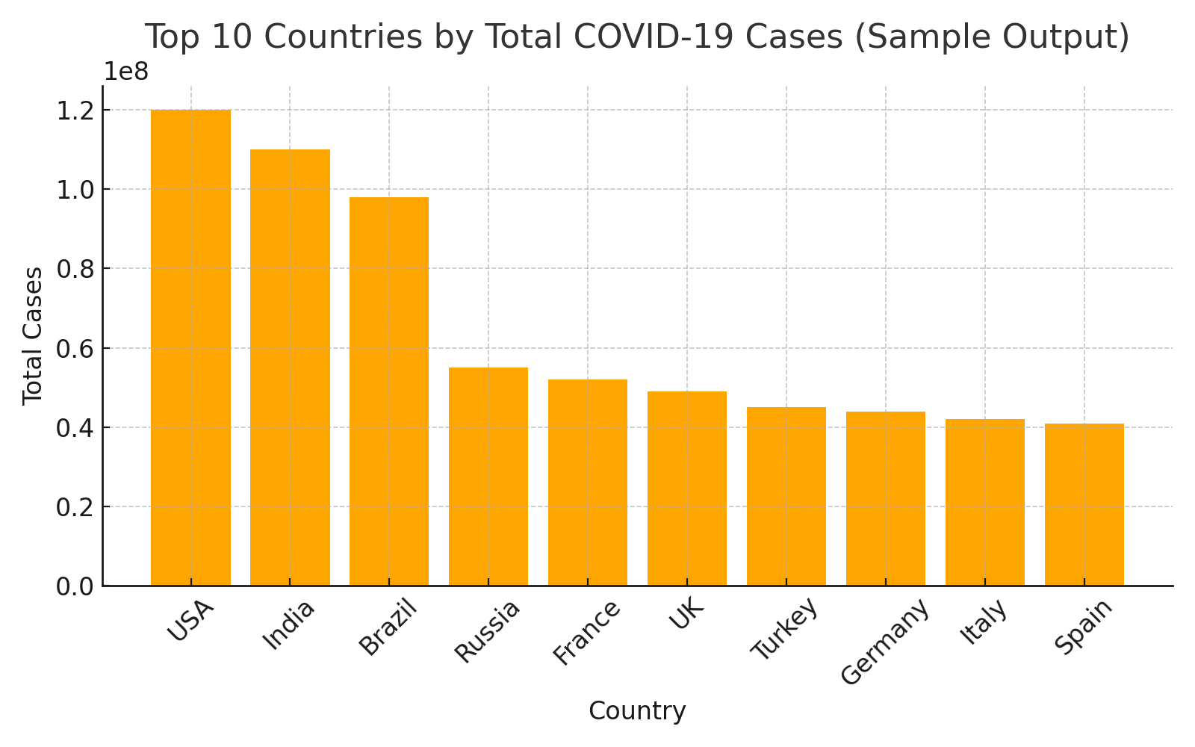
2. Screenshot 2: Pie chart showing death distribution among the same countries.
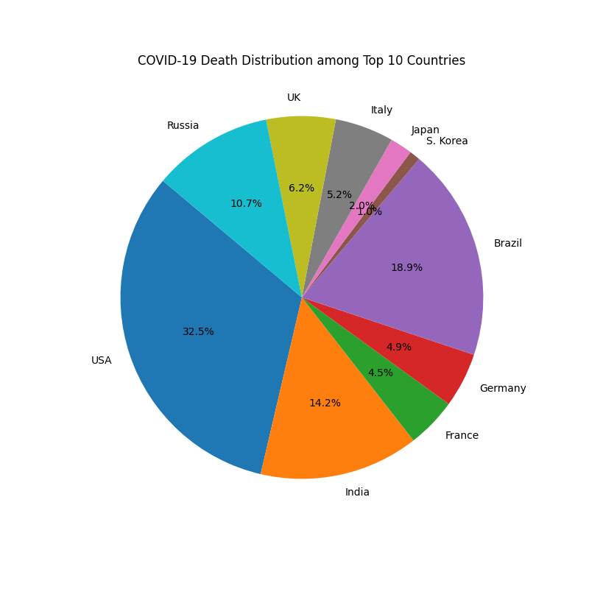

6. Results and Conclusion
The project successfully retrieves up-to-date COVID-19 data and visualizes it through bar and pie charts. Users can easily understand which countries are most affected and compare the number of deaths visually.
What I learned:
- How to use APIs to fetch real-time data.
- Data cleaning and sorting with pandas.
- Building multiple types of visualizations with matplotlib.
Future improvements:
- Add a time-series line chart to show daily case growth.
- Create an interactive dashboard using Plotly or Dash.
- Add options for users to filter regions or continents.

7. References
Although this is an original project, the following resources were used for documentation:
- https://disease.sh/docs/
- https://matplotlib.org/stable/
- https://pandas.pydata.org/docs/

